2023 Red, White & Blue Brunch

Keynote Speakers:

Hon. Jeanne Ives Frank DiFranco, Esq.
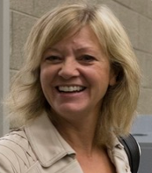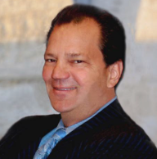
Frank Gaffney
Founder, Center for Security Policy
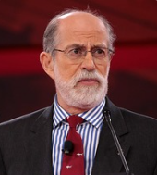

Sunday, Nov. 19, 2023, at 11:30am
doors open at 11:00am

Park Ridge Country Club
636 North Prospect Avenue, Park Ridge

$50 pre-paid admission per guest/$380 for a table of 8 on a single check RSVP by Nov. 14 via the enclosed form;
pre-paid reservations will be held at the door. For more information, phone Alicia Bailey at (773) 636-7346.

A copy of the report of the Republican Women of Park Ridge filed with the State Board of Elections is (or will be) available on the Board’s
official website (www.elections.il.gov) or for purchase from the State Board of Elections, Springfield, Illinois

2023 Red, White & Blue Brunch
R.S.V.P. Form

__ I accept your invitation to brunch
__ Pre-paid reservations at $50 per guest
__ Table of eight at $380 via single check/payment
(Please list attendee names on back of form)

___I am unable to attend, but wish to contribute $_____ to help RWOPR
__ I would like to become a member of RWOPR, please accept my annual dues of $25 ($15 for seniors)

Name: ______________________________ Address: ______________________________

Phone: ______________________________ Email: _______________________________

Payment Options:

- Pay online via Zelle @ info.RWOPR@gmail.com by November 14, 2023; please specific “tickets” or “membership” in the memo field (if paying online for membership, please email your contact information to rwopr@ymail.com so we can add you to our mailing list).

- Mail this completed form with your check (payable to Republican Women of Park Ridge) by November 14, 2023 to the address below:

Republican Women of Park Ridge
c/o Donna Adam
612 S. Fifth Ave.
Des Plaines, IL 60016

A copy of our report filed with the State Board of Elections is (or will be) available on the Board’s official
website (www.elections.il.gov) or for purchase from the State Board of Elections, Springfield, Illinois

